**HTML Assignment –by K Jyothi Gangarsha**

**Q1.**

<!DOCTYPE html>

<html lang="en">

<head>

    <meta charset="UTF-8">

    <meta http-equiv="X-UA-Compatible" content="IE=edge">

    <meta name="viewport" content="width=device-width, initial-scale=1.0">

    <title>q1</title>

</head>

<body style="background-color: yellow;">

    <h1 style="background-color: red;">This is a heading</h1>

    <p style="background-color: green; font-size:larger;">

        This is a paragraph

    </p>

</body>

</html>

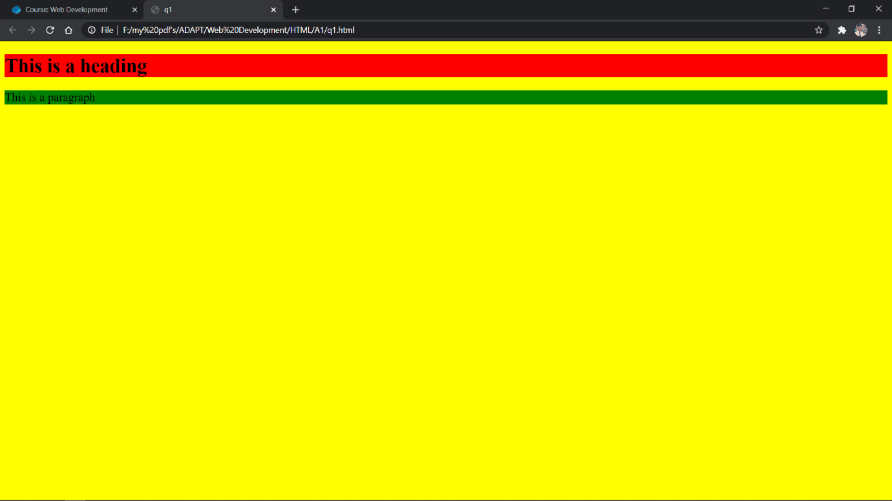

Q2.

<!DOCTYPE html>

<html lang="en">

<head>

    <meta charset="UTF-8">

    <meta http-equiv="X-UA-Compatible" content="IE=edge">

    <meta name="viewport" content="width=device-width, initial-scale=1.0">

    <title>q2</title>

</head>

<body>

    Create a link of an image: <fieldset style="width:2px">&#128522;</fieldset>

    No border around the image, but still a link: &#128522;

</body>

</html>

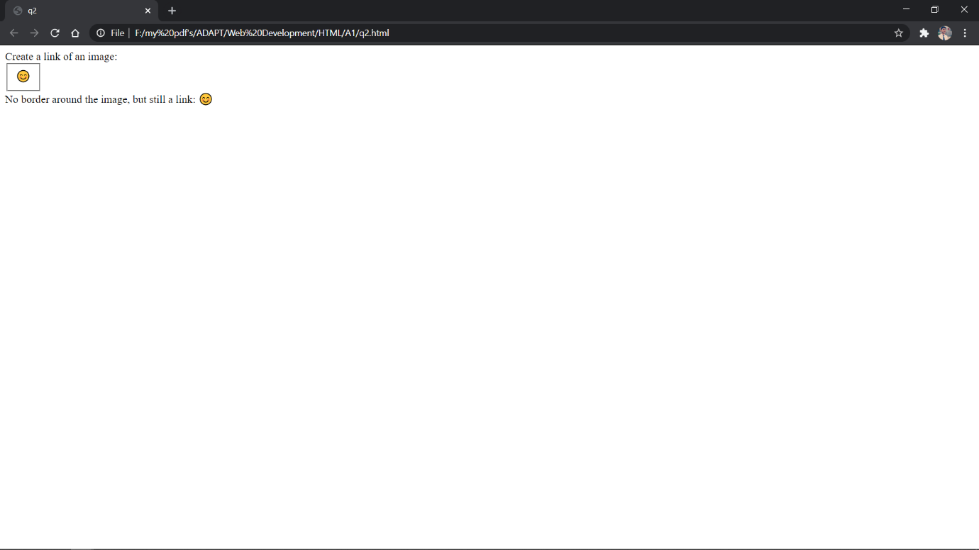

Q3.

<!DOCTYPE html>

<html lang="en">

<head>

    <meta charset="UTF-8">

    <meta http-equiv="X-UA-Compatible" content="IE=edge">

    <meta name="viewport" content="width=device-width, initial-scale=1.0">

    <title>q3</title>

</head>

<h2>One Column:</h2>

<head>

    <style>table, td{border: 1px solid black;}</style>

</head>

<body>

    <table>

        <tr>

            <td>100</td>

        </tr>

    </table>

</body>

<h2>One row and Column:</h2>

<head>

    <style>table, td{border: 1px solid black;}</style>

</head>

<body>

    <table>

        <tr>

            <td>100</td>

            <td>200</td>

            <td>300</td>

        </tr>

    </table>

</body>

<h2>Two rows and three Columns:</h2>

<head>

    <style>table, td{border: 1px solid black;}</style>

</head>

<body>

    <table>

        <tr>

            <td>100</td>

            <td>200</td>

            <td>300</td>

        </tr>

        <tr>

            <td>400</td>

            <td>500</td>

            <td>600</td>

        </tr>

    </table>

</body>

</html>

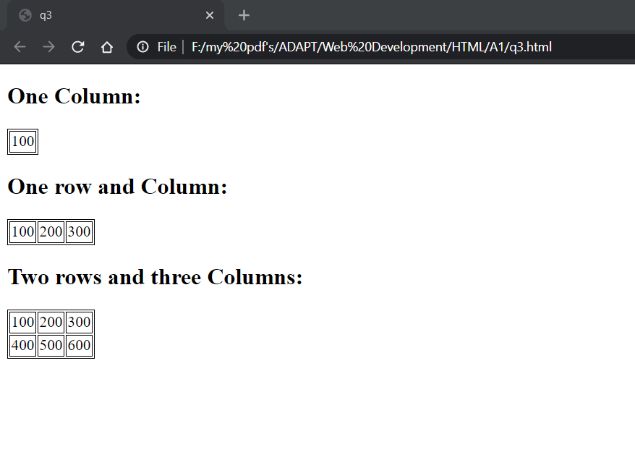

Q4.

<!DOCTYPE html>

<html lang="en">

<head>

    <meta charset="UTF-8">

    <meta http-equiv="X-UA-Compatible" content="IE=edge">

    <meta name="viewport" content="width=device-width, initial-scale=1.0">

    <title>q4</title>

</head>

<body>

    <table colspan="3"> This table has borders:

        <tr>

            <td><fieldset>100</fieldset></td>

            <td><fieldset>200</fieldset></td>

            <td><fieldset>300</fieldset></td>

        </tr>

        <tr>

            <td><fieldset>400</fieldset></td>

            <td><fieldset>500</fieldset></td>

            <td><fieldset>600</fieldset></td>

        </tr>

    </table>

<table colspan="3"> And this table has no borders:

    <tr>

        <td>100</td>

        <td>200</td>

        <td>300</td>

    </tr>

    <tr>

        <td>400</td>

        <td>500</td>

        <td>600</td>

    </tr>

</table>

</body>

</html>

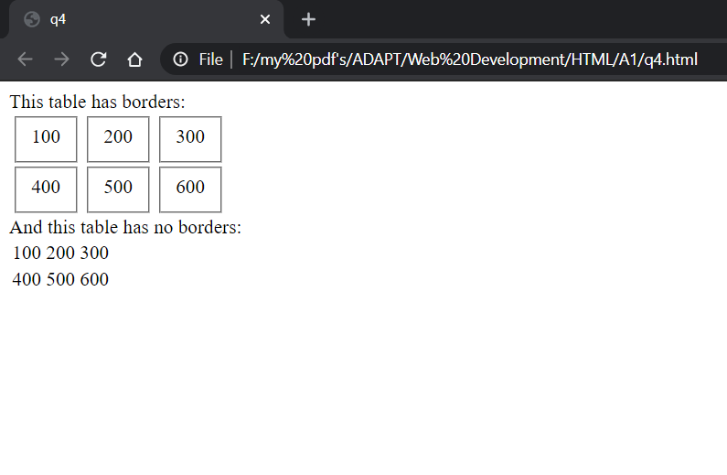

Q5.

<!DOCTYPE html>

<html lang="en">

<head>

    <meta charset="UTF-8">

    <meta http-equiv="X-UA-Compatible" content="IE=edge">

    <meta name="viewport" content="width=device-width, initial-scale=1.0">

    <title>q5</title>

</head>

<head>

    <h2> Number List:</h2>

    <ol type="1">

        <li>Apples</li>

        <li>Bananas</li>

        <li>Lemons</li>

        <li>Oranges</li>

    </ol>

    <h2> Letter List:</h2>

    <ol type="A">

        <li>Apples</li>

        <li>Bananas</li>

        <li>Lemons</li>

        <li>Oranges</li>

    </ol>

    <h2> Lowercase Letters List:</h2>

    <ol type="a">

        <li>Apples</li>

        <li>Bananas</li>

        <li>Lemons</li>

        <li>Oranges</li>

    </ol>

    <h2> Roman Number List:</h2>

    <ol type="I">

        <li>Apples</li>

        <li>Bananas</li>

        <li>Lemons</li>

        <li>Oranges</li>

    </ol>

    <h2> Lowercase Roman List:</h2>

    <ol type="i">

        <li>Apples</li>

        <li>Bananas</li>

        <li>Lemons</li>

        <li>Oranges</li>

    </ol>

</head>

</html>

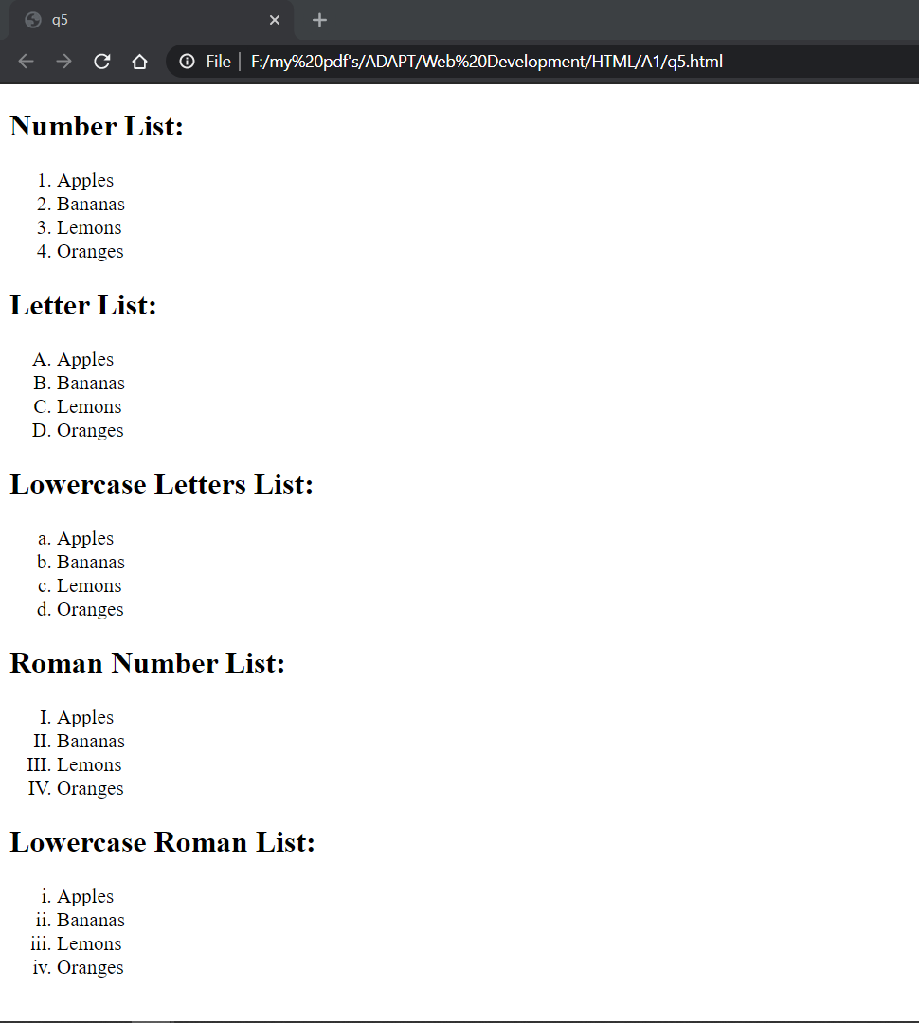

Q6.

<!DOCTYPE html>

<html lang="en">

<head>

    <meta charset="UTF-8">

    <meta http-equiv="X-UA-Compatible" content="IE=edge">

    <meta name="viewport" content="width=device-width, initial-scale=1.0">

    <title>q6</title>

</head>

<body>

    <form>

        <div>

            <label for="username">Username</label>

            <input type="text" name="username"id="username">

        </div>

        <div>

            <label for="password">Password</label>

            <input type="password" name="password"id="password">

        </div>

    </form>

</body>

</html>

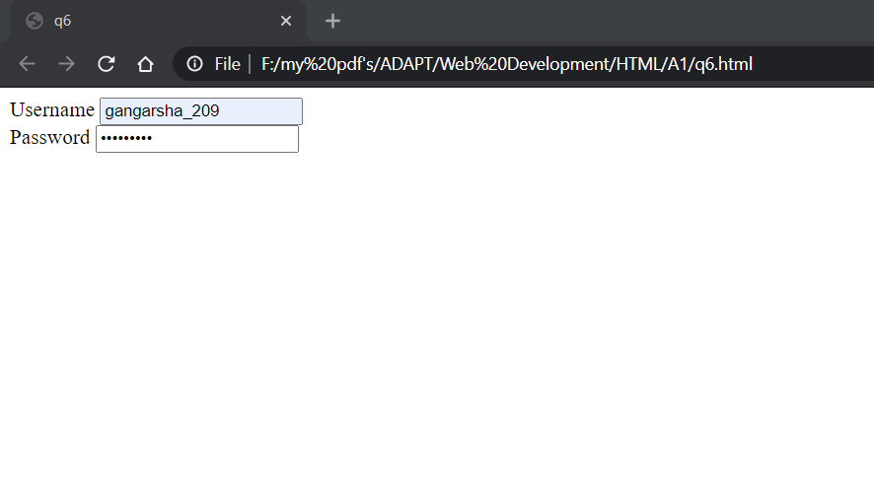

Q7.

<!DOCTYPE html>

<html lang="en">

<head>

    <meta charset="UTF-8">

    <meta http-equiv="X-UA-Compatible" content="IE=edge">

    <meta name="viewport" content="width=device-width, initial-scale=1.0">

    <title>q7</title>

</head>

<body>

    <form>

        <div>

            <input type="checkbox" name="I have a Bike" id="I have a Bike">

            <label for="I have a Bike">I have a Bike</label><br/>

            <input type="checkbox" name="I have a car" id="I have a car">

            <label for="I have a car">I have a car</label><br/>

        </div>

        <input type="submit" name="submit">

    </form>

</body>

</html>

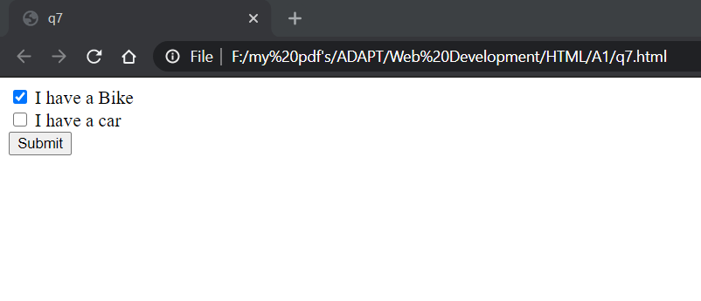

Q8.

<!DOCTYPE html>

<html lang="en">

<head>

    <meta charset="UTF-8">

    <title>Q8</title>

</head>

<frameset rows="20%,80%">

    <frame style="background-color: teal;" src="top.html"/>

    <frameset cols="50%,50%">

        <frame style="background-color: grey;" src="left-frame.html"/>

        <frame style="background-color:thistle;" src="right-frame.html"/>

    </frameset>

</frameset>

</html>

<!DOCTYPE html>

<html lang="en">

<head>

    <meta charset="UTF-8">

    <title>top</title>

</head>

<body>

<h1>Top</h1>

</body>

</html>

<!DOCTYPE html>

<html lang="en">

<head>

    <meta charset="UTF-8">

    <title>left</title>

</head>

<body>

<h1>left</h1>

</body>

</html>

<!DOCTYPE html>

<html lang="en">

<head>

    <meta charset="UTF-8">

    <title>right</title>

</head>

<body>

<h1 style="text-align:left;">right</h1>

</body>

</html>

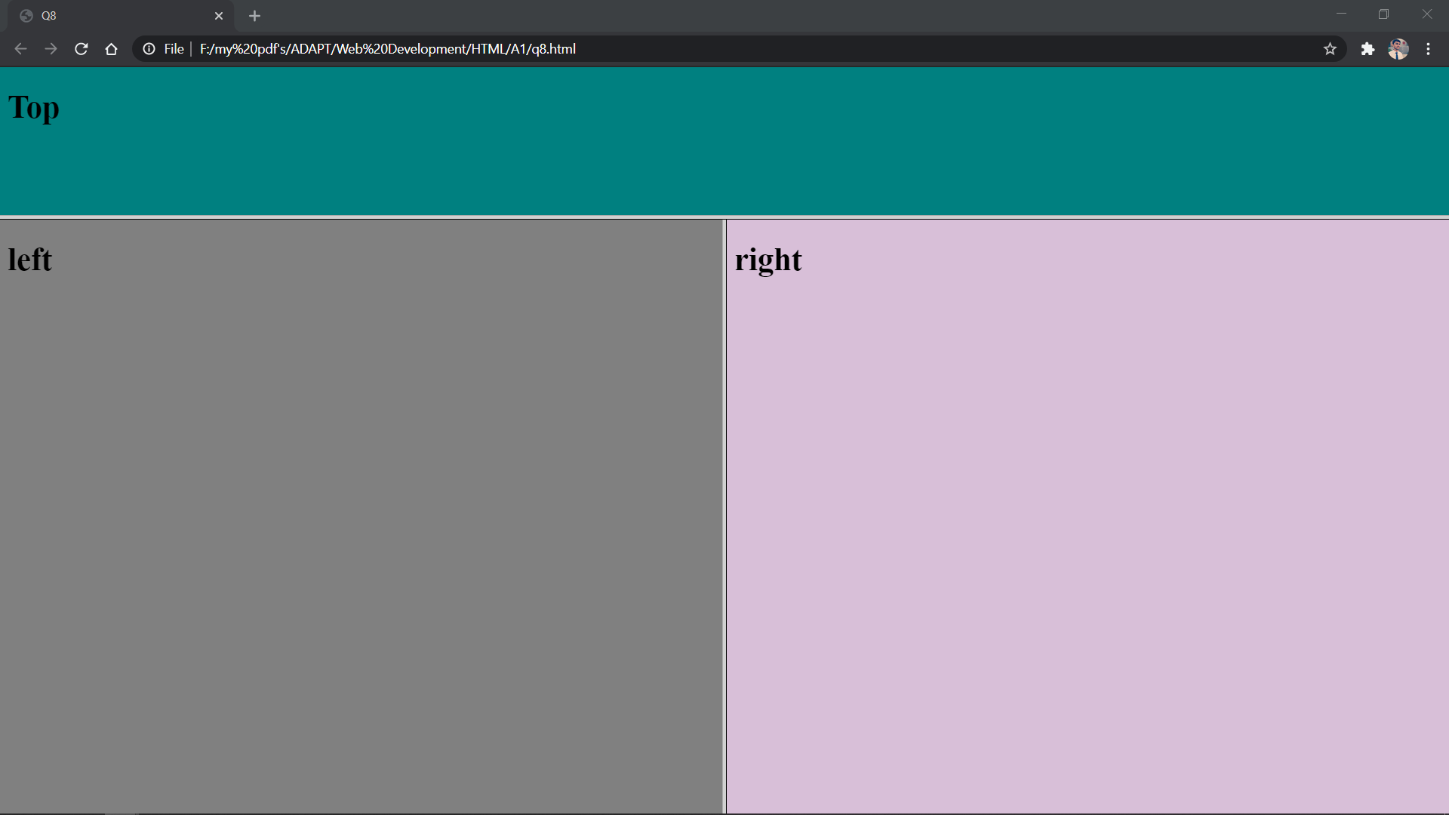

Q9.

<!DOCTYPE html>

<html lang="en">

<head>

    <meta charset="UTF-8">

    <title>Q8</title>

</head>

<frameset rows="20%,80%" cols="50%,50%">

    <frame style="background-color:thistle;" src="topleft.html"/>

    <frame style="background-color:gray;" src="topright.html"/>

    <frame style="background-color: gray;" src="bottom left-frame.html"/>

    <frame style="background-color:thistle;" src="bottom right-frame.html"/>

</frameset>

</html>

<!DOCTYPE html>

<html lang="en">

<head>

    <meta charset="UTF-8">

    <title>topleft</title>

</head>

<body>

<h1 style="text-align: center;">topleft</h1>

</body>

</html>

<!DOCTYPE html>

<html lang="en">

<head>

    <meta charset="UTF-8">

    <title>topright</title>

</head>

<body>

<h1 style="text-align: center;">topright</h1>

</body>

</html>

<!DOCTYPE html>

<html lang="en">

<head>

    <meta charset="UTF-8">

    <title>bottomleft</title>

</head>

<body>

<h1 style="text-align:center;">botleft</h1>

</body>

</html>

<!DOCTYPE html>

<html lang="en">

<head>

    <meta charset="UTF-8">

    <title>bottomright</title>

</head>

<body>

<h1 style="text-align: center;">botright</h1>

</body>

</html>

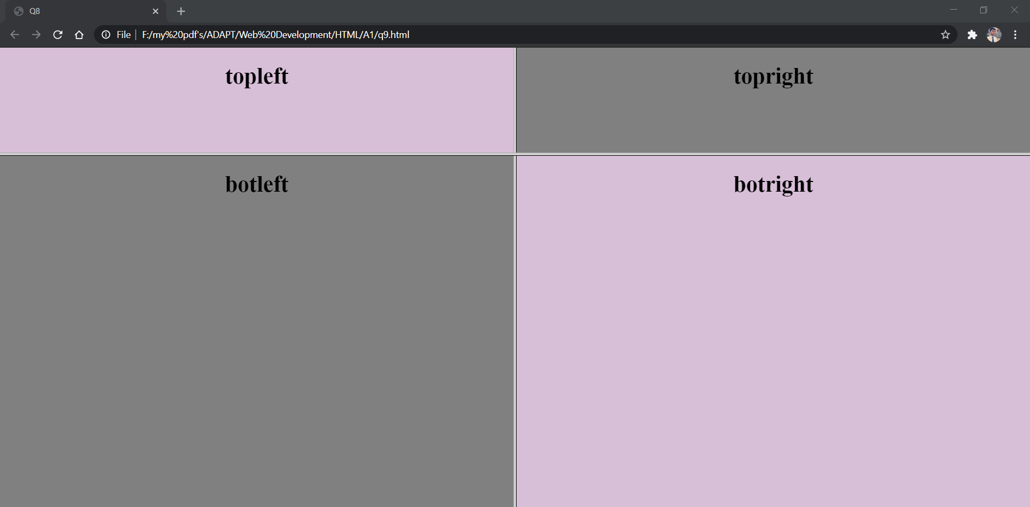

---Thankyou---